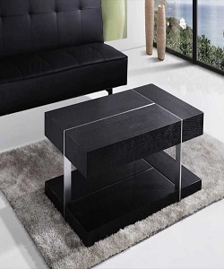

Table

$78.43

Availability: In stock

Description:

The black simple table brings a bit of contemporary appeal to any ensemble in your home. A clear matte top provides a place for any items you want to show off, finish for an on-trend look. This design is perfect look for living room. Assembly is required.